Vacancy! Outdoor Learning Officer

Thanks to the Ernest Cook Trust, The Friendship Café is now in the position to offer
an opportunity for a part-time Outdoor Learning Officer.

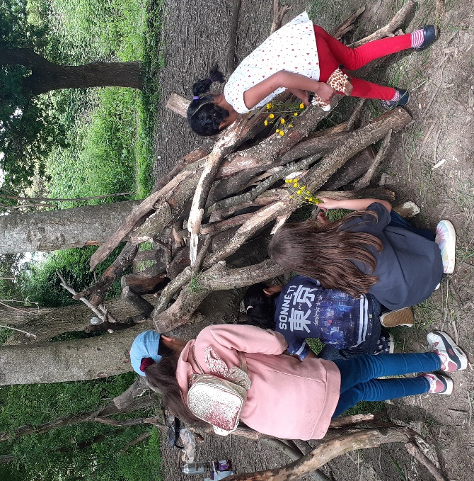
Starting gross salary £24988 per annum (pro rata FTE) actual £12’494 gross for 17.5 hours week (3 years funding from September 2023, permanent thereafter subject to funding).
24 days holiday plus bank holidays (pro rata FTE)

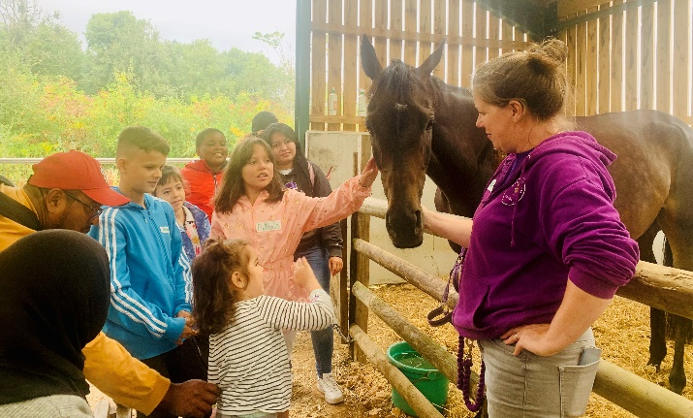

Keen outdoor type? Good organiser? Able to communicate and work on own initiative and with others to build links?
Our aim is to build upon the existing provision of Outdoor Learning in a culturally sensitive manner for people from the inner city area (Barton & Tredworth and surrounding wards).
We want to develop the local community and support families to participate in countryside learning activities that they might not otherwise have the opportunity to join.

The work will involve regular working on weekends.


For further information see the job description and person specification or to receive an application form, please contact:
Imran 01452 308127 imran@thefriendshipcafe.com

Closing date for completed applications: 14 June 2023

If you do not hear within 2 weeks of the closing date, please assume that you have been unsuccessful on this occasion. We do not have the administrative capacity to respond to every application so only shortlisted candidates will be contacted.
NO AGENCIES PLEASE.
In line with The FC Safeguarding Policy, appointments will be subject to an enhanced DBS check and satisfactory references.
Safeguarding is everyone’s business. There is an expectation and a requirement that staff/volunteers will pass any child/vulnerable adult welfare concerns that may arise in the course of their duties to The FC Designated Safeguarding Lead.

